Table of Contents

RxStation User Guide
Small label printing made simple — for the whole pharmacy team.

How to read this guide
Every part of the guide follows the same style, so you always know where to look.
- A red box around a button or a box shows you where to click or where to type.
- A red number inside a red circle (like ①②③) tells you the order of the steps. Step 1 first, then Step 2, and so on. The same number appears next to the step in the words below.
- A red dashed arrow points at the exact spot to look.
If the on-screen button shows a small picture like 🖨 or ✓, this guide keeps the picture too. That way the word on the page is the same as the word on the screen.

1. Welcome
RxStation is the little helper that prints pharmacy labels for every drug box, bottle, or vial in the ward. You scan a barcode (or type a short code), and RxStation prints a neat sticker with the drug name, the batch number, and the expiry date.
This guide walks you through every page and every button in the app. If you have never used RxStation before, start at Chapter 2 and work down. If you already know the app and just want one job done fast, jump to Chapter 9 — Everyday Recipes.

2. First Look at the Main Window
When RxStation starts, you land on Drug Enquiry. The rest of the app lives on the white rail on the left. Six buttons — that is all the navigation you need.
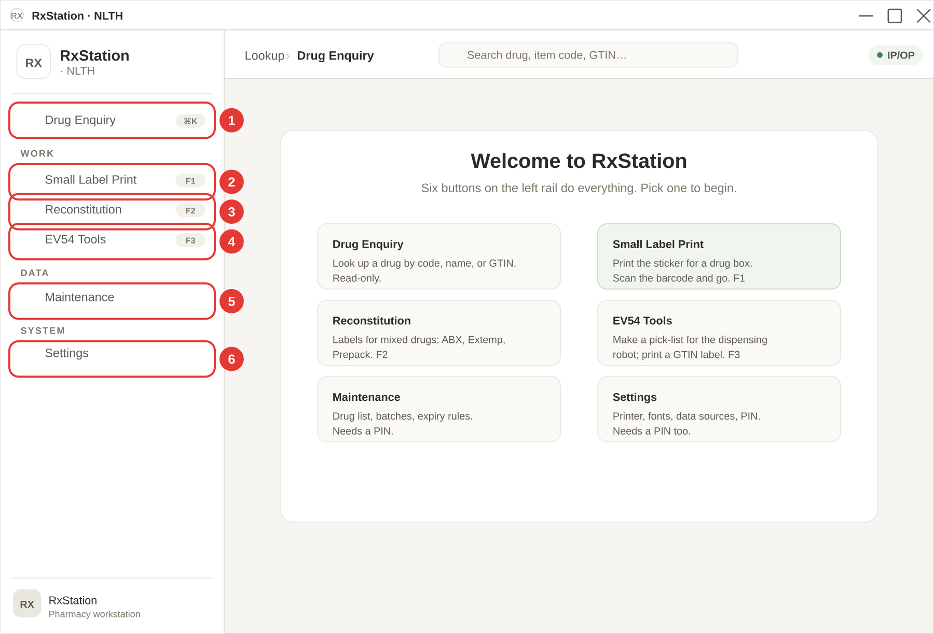
Follow the red numbers on the picture above.
① Drug Enquiry. Look up any drug by code, name, or GTIN. Read-only — no labels are printed from here. The keyboard shortcut is Ctrl+K (written as ⌘K on the badge).
② Small Label Print. The page you will use most. Scan a barcode or type a 6-character item code, and RxStation prints the sticker that goes on the drug box or vial. Shortcut: F1.
③ Reconstitution. For compounded drugs — ABX, Extemporaneous, and Prepack. Each one has its own tab. Shortcut: F2.
④ EV54 Tools. Two jobs for the EV54 robot — print a pick-list when you refill the robot, or print a GTIN QR label for a bottle. Shortcut: F3.
⑤ Maintenance. Drug list, expiry rules, GTIN database, batch history. Needs a PIN before it lets you in (Chapter 7).
⑥ Settings. Printer, fonts, paper size, data sources, PIN change, feature flags. Also needs the PIN (Chapter 8).
The top bar shows a breadcrumb (Lookup › Drug Enquiry), a global Search drug, item code, GTIN… box, and a small green chip showing the current Location (usually IP/OP).
Tip: If some of the six buttons are missing on your PC, an admin has turned them off in Settings → Admin. Ask the admin to turn them back on (Chapter 8b).

What if something goes wrong?
- The rail shows fewer than six buttons. An admin has hidden one in Settings → Admin → Main Menu Pages. See Chapter 8b.
- F1 / F2 / F3 do nothing. Click the rail button once with the mouse first. Some windows need the app to have keyboard focus before shortcuts work.

3. Drug Enquiry
Drug Enquiry is the lookup page. Type any part of a drug name, item code, or GTIN, and the table below filters as you type. It is read-only — no labels are printed from here. For printing, use Small Label Print (Chapter 4).
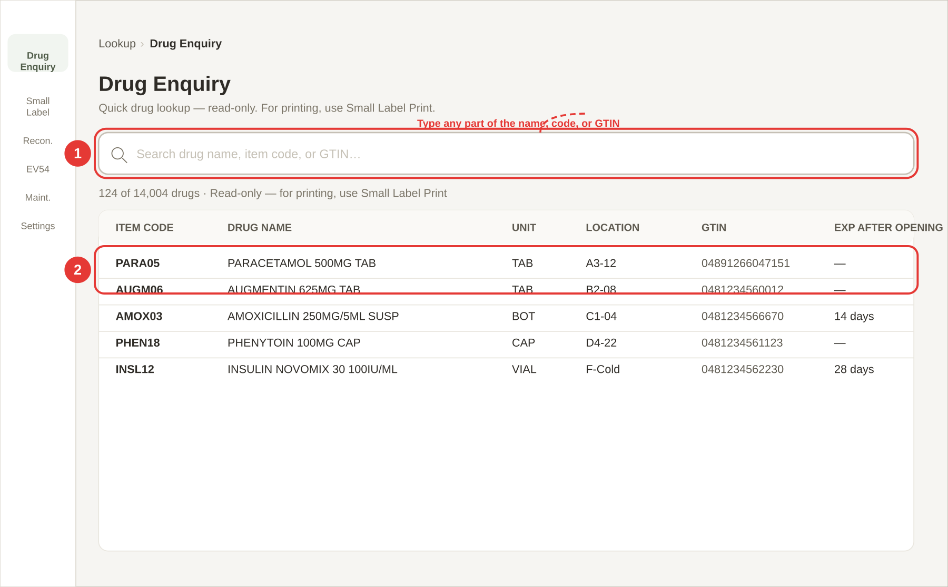
Follow the red numbers on the picture above.
① Click inside the search box and start typing. The box is labelled Search drug name, item code, or GTIN…. The table below the box updates as you type — there is no Enter key needed. You can type:
- Part of a drug name — for example parac finds PARACETAMOL.
- Part of an item code — for example PARA or PARA05.
- Part of a GTIN — for example the last 6 digits of the barcode number.
Upper or lower case does not matter.
② Read the row. Every match shows six columns:
- Item code — the 6-character code (copy this if you need to print a label).
- Drug name — the full drug name and strength.
- Unit — TAB, BOT, VIAL, CAP, etc.
- Location — the shelf/bin where the drug is kept. Shown as a pale green pill.
- GTIN — the 13- or 14-digit barcode number.
- Exp after opening — how many days the opened vial/bottle stays good for (only for drugs that have a rule).
At the top of the table you will see something like 124 of 14,004 drugs — the first number is how many match your search, the second is the total in the drug list. A maximum of 200 rows is shown at one time — narrow your search if your drug is not on screen.

What if something goes wrong?
- "No drugs loaded. Import drug data in Maintenance." — The drug list has not been imported yet. An admin needs to go to Maintenance → Import Excel → Drugs (PHQ) (see Chapter 7d).
- "No drugs match "…"" — Your search string is not in the list. Try a shorter search — for example amox instead of amoxicillin 250. If you are sure the drug should be there, import the latest drug list.
- The Location column shows — — The drug has no shelf location recorded. Ask the senior staff to update Maintenance → Import Excel → Item Locations.

4. Small Label Print
The Small Label Print page is the one you will use most. It prints the small sticker that goes on every drug box or bottle. The page has two tabs — pick the one that fits your job.
Tab | When to use it
Standard Label | For a normal drug box. Scan the barcode, or type a 6-letter item code, and press Enter.
Short Exp (After Opening) | For a vial or bottle that has just been opened. The app works out the new expiry date for you.

4a. Standard Label — step by step
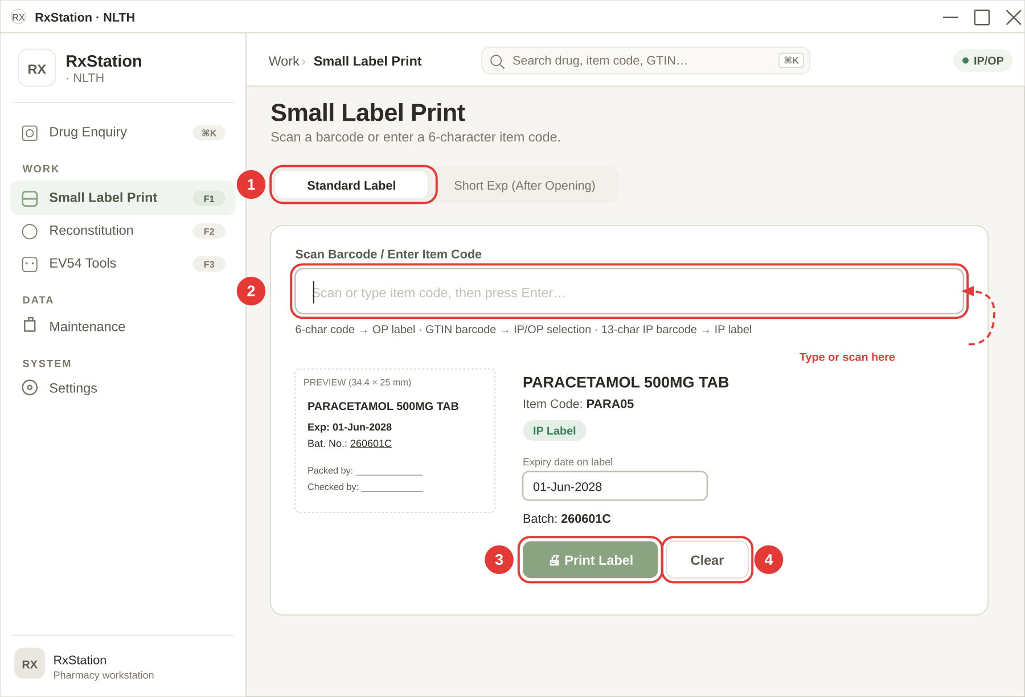
Follow the red numbers on the picture above.
① Make sure the Standard Label tab is on. When you open the page, this tab is already on by default. If you ever see Short Exp (After Opening) on instead, just click Standard Label once.
② Click inside the big scan box, then scan or type. The box is labelled Scan Barcode / Enter Item Code. You can use it three different ways:
- Scan a GTIN barcode on the drug box. Point the scanner at the barcode. The app reads the item code, the batch number, and the expiry date in one go, and a small window pops up asking In-Patient (IP) or Out-Patient (OP). Pick one and the label prints.
- Scan a 13-digit IP barcode. Same — just scan. The app pulls out the item code for you.
- Type a 6-letter item code. For example PARA05. After you type, press Enter on the keyboard. The label will print as an OP label (no expiry date).
If you do not know the code, open Drug Enquiry (Chapter 3) in another window to look it up first.
③ Click 🖨 Print Label to print. If the app printed on its own after the scan, you do not have to press this button — it has already done the job. You only need to press 🖨 Print Label when you typed or changed something (like a new expiry date) and want to send the label to the printer yourself.
④ Click Clear to start a new one. Clear wipes the drug name, batch, and expiry from the screen so you can scan the next box. It does not delete anything from your records — it only clears the screen.

Typing an expiry date by hand (for IP labels only)
Some drug boxes do not have the expiry inside the barcode. When this happens, the app leaves the Expiry date on label box empty and waits for you.
- Click inside the Expiry date on label box.
- Type the date as eight digits with no spaces. Day, month, year. Example: 01062028 for 1 June 2028.
- As soon as you finish, the app changes it to the pretty form: 01-Jun-2028. You do not need to press Enter.
- If you prefer, you can also type the pretty form yourself, like 01-Jun-2028. The app will tidy the letters.
- When you are happy, press 🖨 Print Label.
OP labels never show an expiry date. The expiry box is only there for IP labels, so if you picked Out-Patient (OP) you will not see this box at all.

What if something goes wrong?
You may see a short message in red. Here is what each one means:
- "Drug not found (XXXXXX). Import your drug list via Maintenance → Import Excel → Drugs (PHQ)." — The 6-letter code is not in the app's drug list. Ask the senior staff to import the latest drug list. Chapter 7d shows how.
- "Could not decode barcode" — The scanner read the barcode but the app could not understand it. Try scanning again slowly. If it keeps failing, Chapter 8 shows how to switch to the Legacy decoder.
- "Unrecognised input. Enter a 6-char item code or scan a barcode." — You typed something too short or too long. Item codes are exactly 6 letters/numbers.
When the label comes out of the printer, you will also see a small green tick — ✓ Label printed — at the bottom of the screen. It disappears by itself after about 1.5 seconds.

Picking IP or OP after a GTIN scan
When you scan a GTIN barcode on a drug box, the app pops up a small window before anything is printed. It needs to know whether this sticker is for an in-patient or an out-patient.
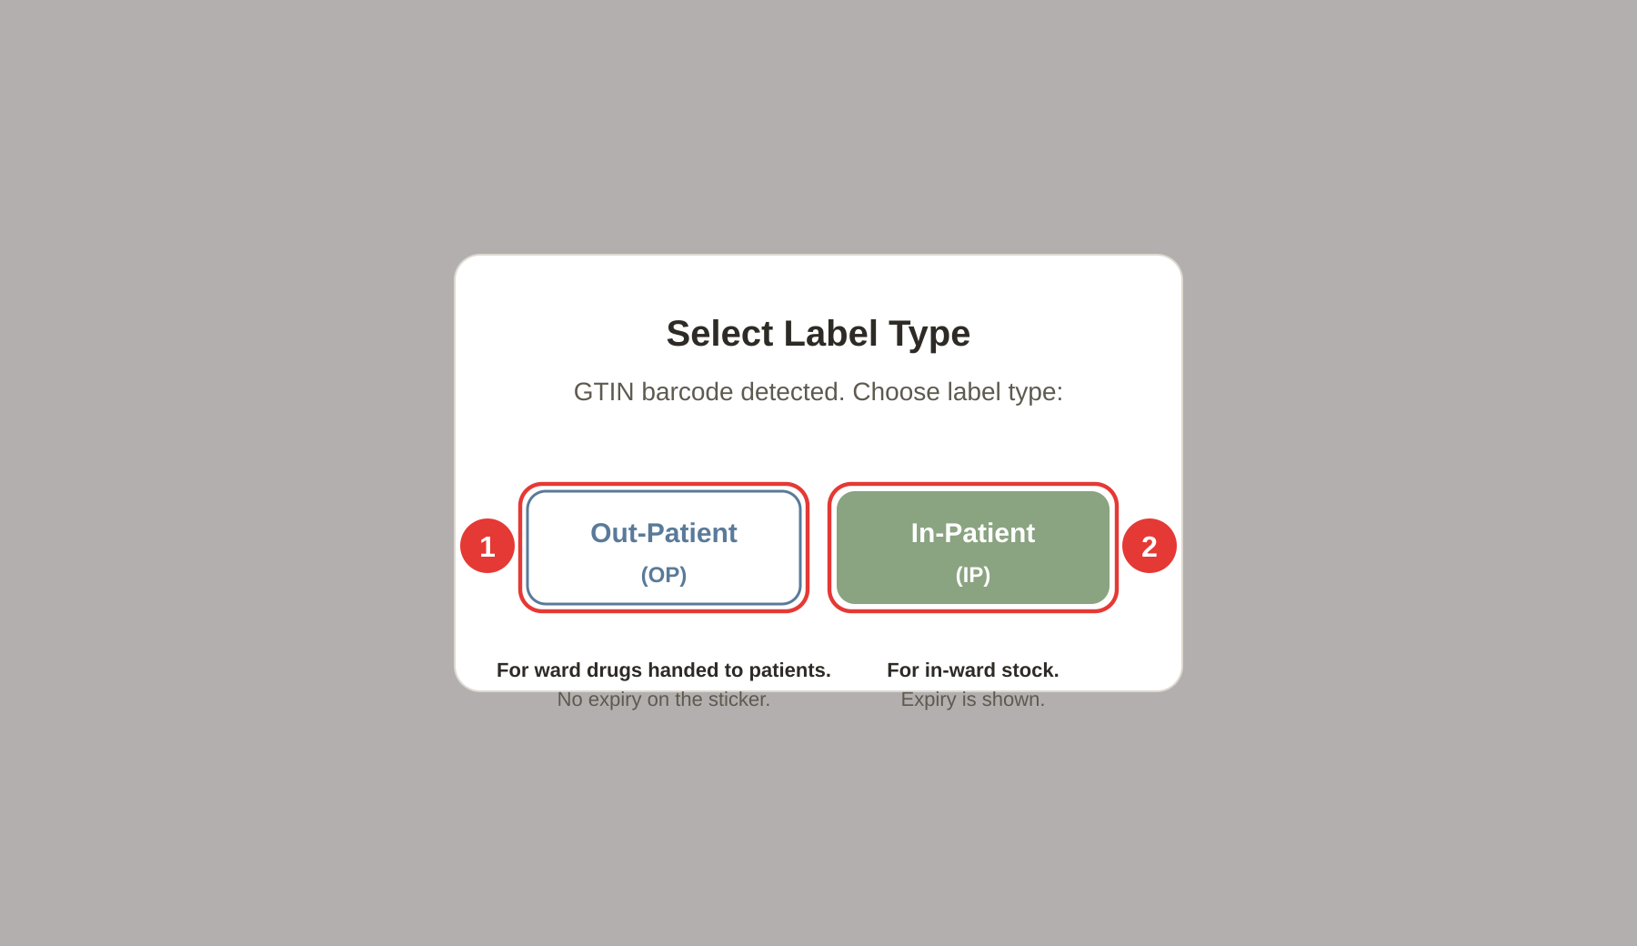
The pop-up reads Select Label Type — GTIN barcode detected. Choose label type. You have two choices.
① Out-Patient (OP). Click this button if the drug is going home with the patient. The printed label will not show an expiry date, even if the barcode had one. This matches HK dispensing policy for OP supplies.
② In-Patient (IP). Click this button if the drug stays on the ward. The printed label will show the expiry date read from the barcode (bold line: Exp: DD-Mon-YYYY).
After you click one of the two buttons:
- If the barcode had both a batch and an expiry, the label prints straight away and the screen clears for the next scan.
- If the barcode was missing the expiry (or you picked IP and the app could not read the expiry), the drug details stay on screen with an empty Expiry date on label box — type the date yourself (see "Typing an expiry date by hand" above) and click 🖨 Print Label.

What is printed on the sticker
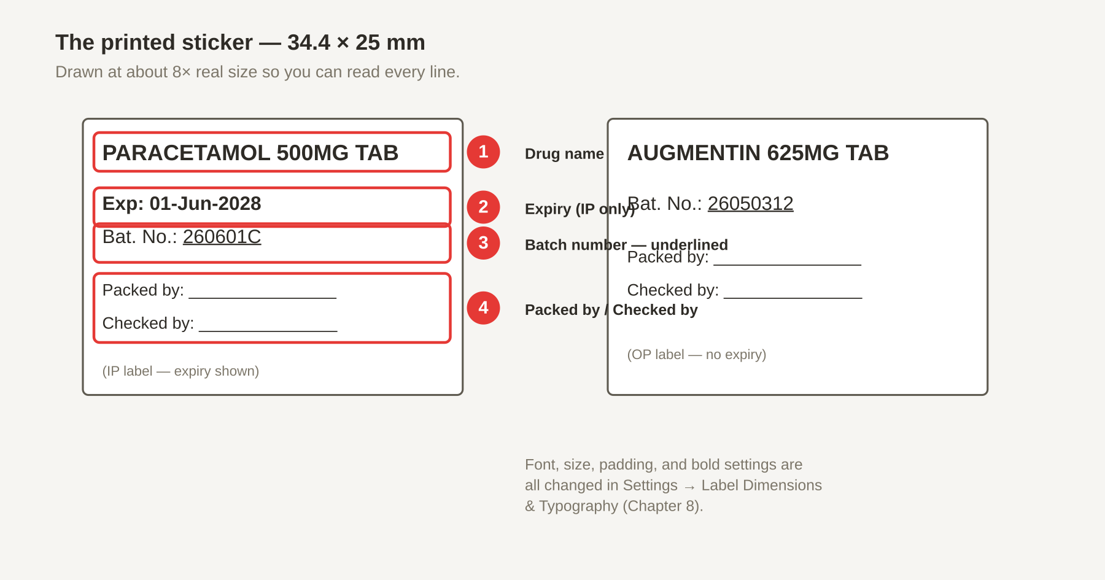
Follow the red numbers on the picture above. The left sticker is an IP label (has the expiry line). The right sticker is an OP label (no expiry line).
① Drug name. The top line — the full item description (for example PARACETAMOL 500MG TAB). Arial 6 pt bold by default.
② Expiry date. Shows only on IP labels. Reads Exp: DD-Mon-YYYY, bold. OP labels skip this line on purpose.
③ Batch number. Bat. No.: 260601C — underlined. If the barcode had no lot number, this line is blank so you can write the batch by hand with a pen.
④ Packed by / Checked by. Two empty lines at the bottom for signatures. Sign with a pen after the sticker is on the box.
The sticker is 34.4 × 25 mm in real life. The picture above is drawn about 8 times bigger so you can read every line. To change the font, the size, the padding, or whether the drug name is bold, go to Settings → Label Dimensions & Typography (Chapter 8a).

4b. Short Exp (After Opening)
The Short Exp tab is for drugs that have just been opened — mostly vials, bottles of syrup, and insulin pens. The factory expiry on the box no longer applies once the seal is broken, so RxStation works out a new, shorter expiry from today using a pre-set rule and prints a fresh sticker.
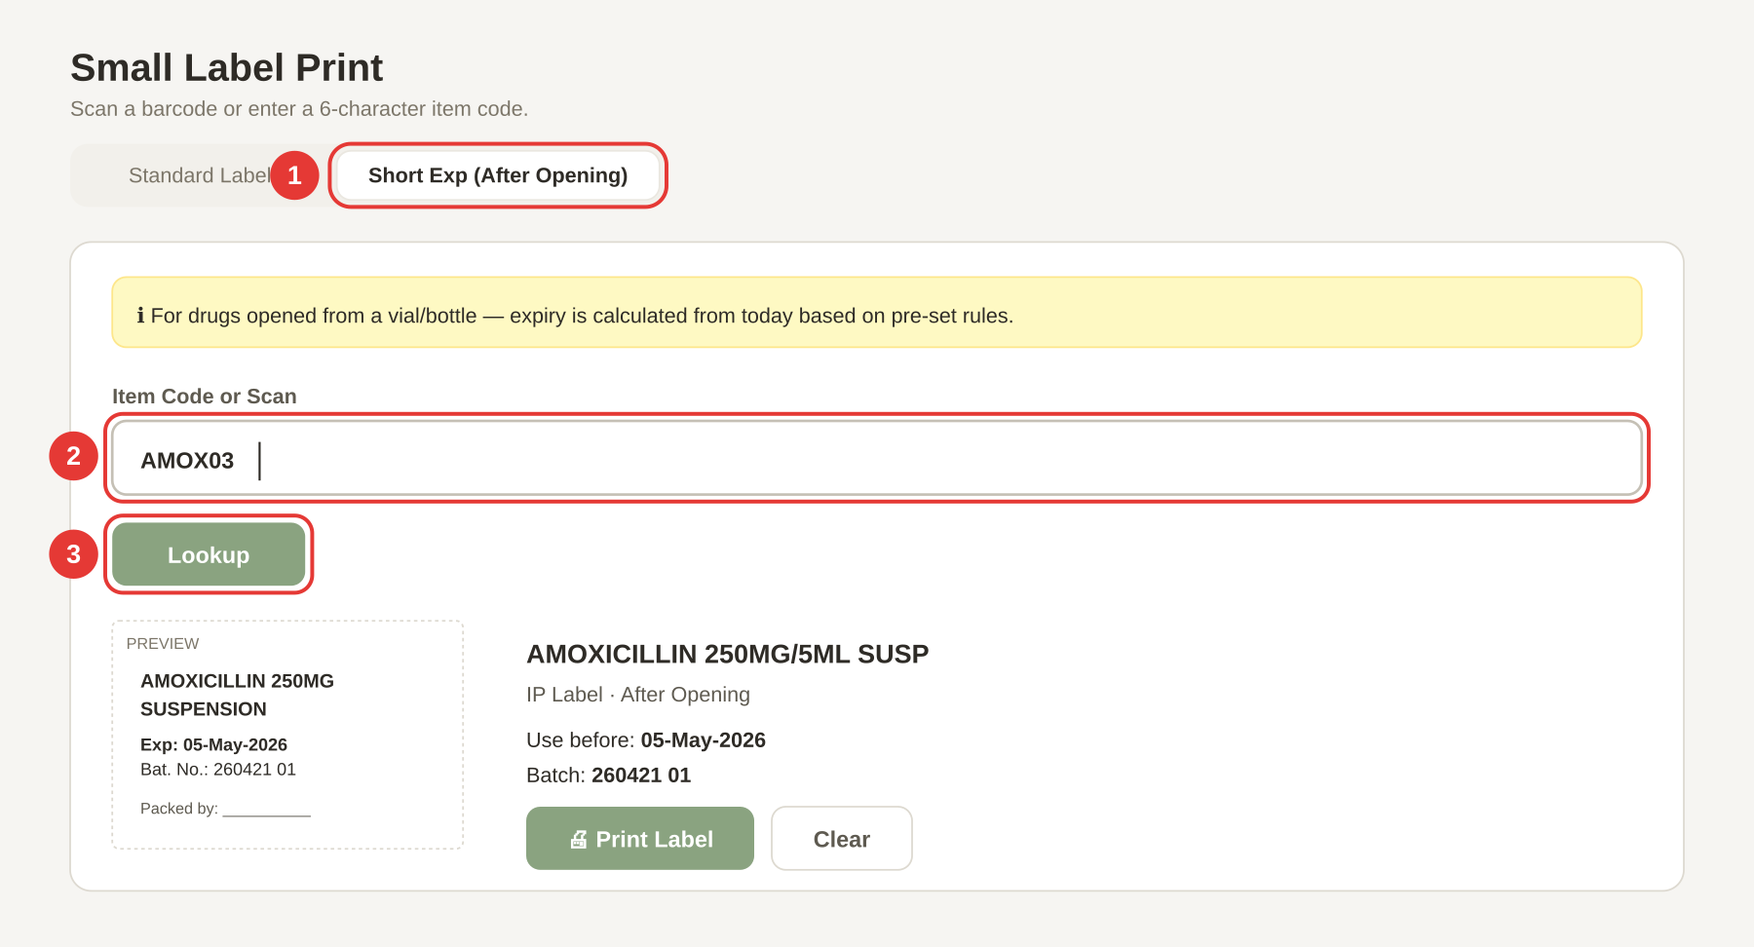
Follow the red numbers on the picture above.
① Click the Short Exp (After Opening) tab. This tab is off by default — the app always opens on Standard Label. Click the tab once and you will see a yellow info banner: ℹ For drugs opened from a vial/bottle — expiry is calculated from today based on pre-set rules.
② Type the 6-character item code in the Item Code or Scan box. For example AMOX03 for Amoxicillin 250 mg/5 ml syrup. You can also scan a barcode here if the scanner is connected. The item code is always 6 characters.
③ Press Enter or click the Lookup button. The app finds the drug, reads the "Exp After Open" rule (for example 14 days), adds that many days to today's date, and makes a new batch number using today's date. The label prints straight away — you do not need a separate Print button for this.
The printed sticker is an IP label with:
- Drug name — from the drug list.
- Exp: DD-Mon-YYYY — today + the number of days in the rule.
- Bat. No.: YYMMDD01 — today's date plus a two-digit sequence number (starts at 01 and goes up if you print more today).
After printing, the ✓ Label printed tick flashes for a moment and the input box clears so you can do the next one.

What if something goes wrong?
- "Item code not found: XXXXXX" — The 6-letter code is not in the app's drug list. Ask the senior staff to import the latest drug list via Maintenance → Import Excel → Drugs (PHQ) (Chapter 7d).
- "No expiry-after-open rule found for this item." — The drug is in the list, but nobody has set up how long it lasts after opening. An admin needs to add the rule in Maintenance → Exp After Open (Chapter 7).
- The new expiry looks wrong. The rule might be out of date. Check Maintenance → Exp After Open — the number in the days column is how many days the drug stays good for after opening.

5. Reconstitution
Reconstitution is where you print labels for drugs that are mixed, compounded, or repacked in the pharmacy. Three tabs — each for a different kind of job.
Tab | When to use it
ABX Preparation | Mixing an antibiotic injection (e.g. Augmentin 1.2g).
Extemporaneous | Making a liquid preparation in-house (e.g. oral syrup).
Prepack | Breaking a bulk bottle down into smaller packs (e.g. 30 tablets per bottle).
All three tabs work the same way: pick an item code, check the numbers the app filled in, and click 🖨 Confirm & Print. The batch number and expiry are worked out for you.

5a. ABX Preparation
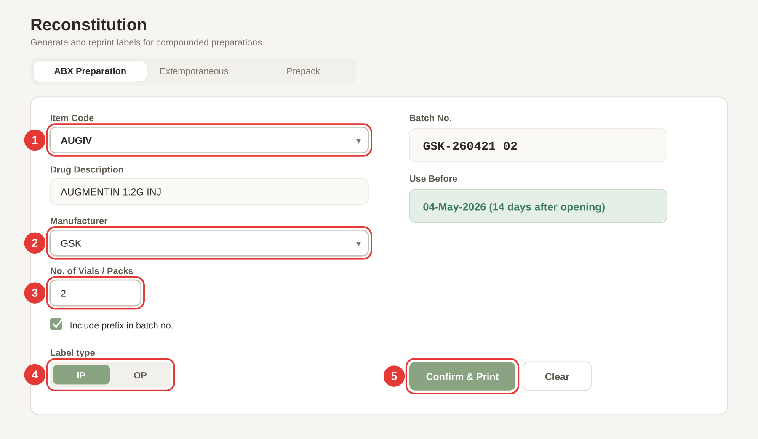
Follow the red numbers on the picture above.
① Choose an item code from the Item Code drop-down. Click the arrow on the right of the box and pick the antibiotic you are mixing (for example AUGIV for Augmentin 1.2g Inj). As soon as you pick, the app fills in Drug Description below.
② Choose a manufacturer from the Manufacturer drop-down. Only the manufacturers with an Active expiry rule for this drug appear here. If the list is empty, an admin needs to add an expiry rule in Maintenance → Expiry Rules. The Use Before date on the right side is worked out from this manufacturer's shelf-life rule (for example 14 days after opening).
③ Set the No. of Vials / Packs. Type the number of vials you are mixing today. The app prints this many small labels plus one extra spare for the batch sheet — so No. of Vials = 2 means 3 labels will come out of the printer.
④ Pick the label type — IP or OP. Use the toggle under Label type. IP labels show the expiry line; OP labels do not. Most ward antibiotics are IP.
⑤ Click 🖨 Confirm & Print. The labels print, a new row is added to Batch History (Maintenance → Batch History), and the batch counter goes up by one for next time. You will see ✓ Labels printed & record saved! flash at the top of the card.
The Batch No. field shows how the batch will look, for example GSK-260421 02 — the manufacturer prefix + today's date + a two-digit counter. Untick Include prefix in batch no. if you do not want the manufacturer prefix on the label.

What if something goes wrong?
- "Please select an item code." — You clicked Confirm & Print without picking an item. Pick one first.
- "Please select a manufacturer." — Same — pick a manufacturer from the drop-down.
- "Could not calculate expiry — check expiry rules in Maintenance." — No Active expiry rule exists for this drug + manufacturer pair. Ask an admin to add one in Maintenance → Expiry Rules.

5b. Extemporaneous
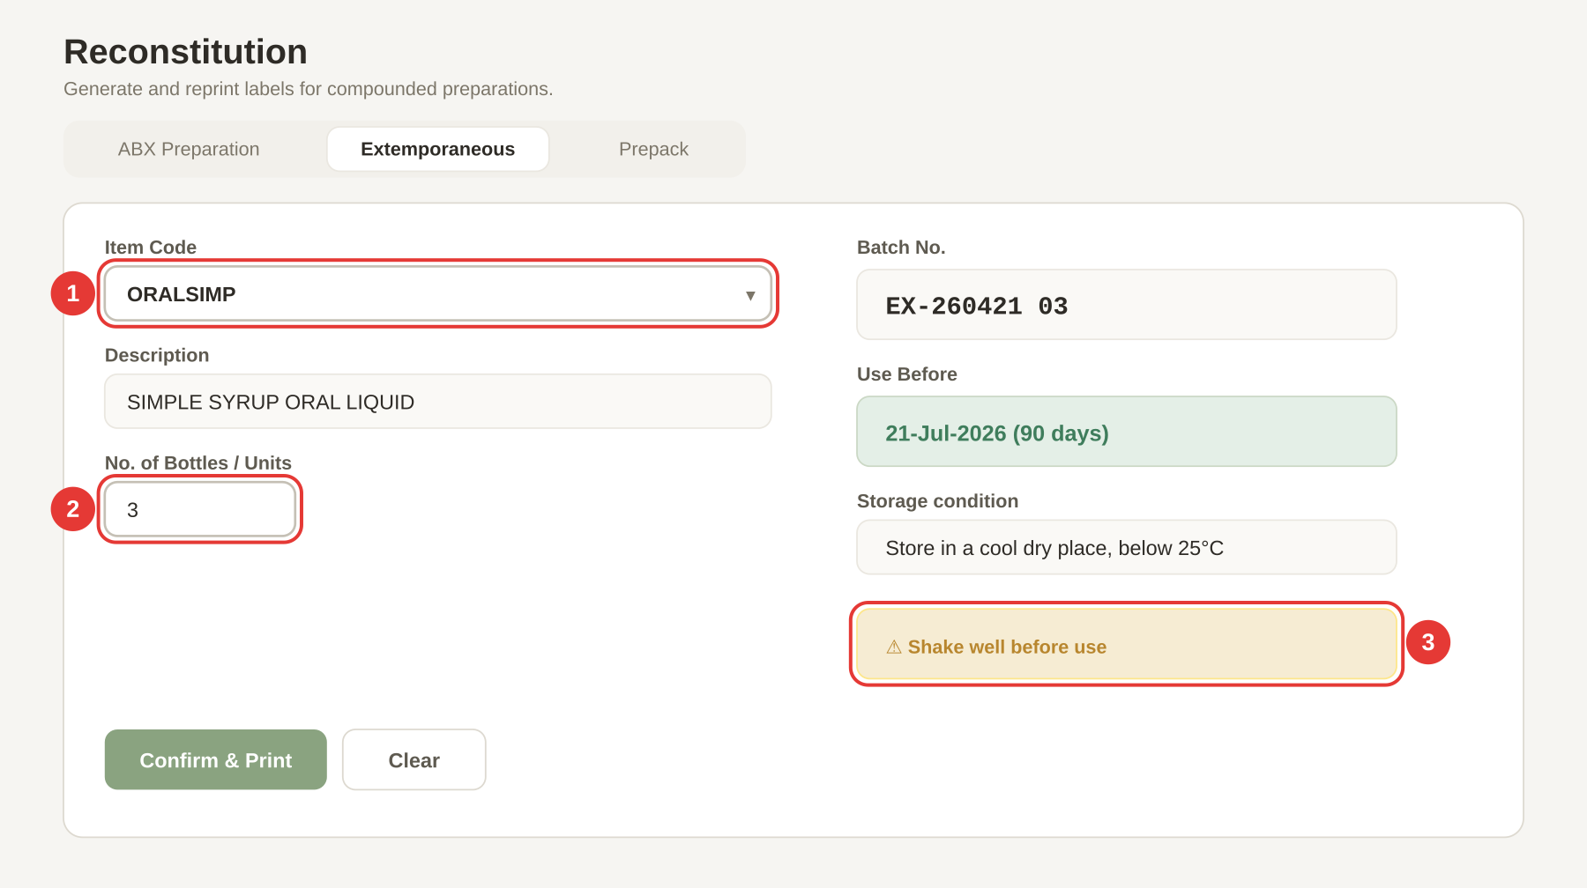
Follow the red numbers on the picture above.
① Choose an item code from the Item Code drop-down. For example ORALSIMP for SIMPLE SYRUP ORAL LIQUID. The app fills in the Description automatically. The Batch No. and Use Before on the right update at the same time, based on the Expiry Rule for this item.
② Type the No. of Bottles / Units. Type how many bottles/units you are making. The app prints enough copies so that each bottle gets 2 labels (one for the bottle, one for the batch sheet). For 3 bottles you will get 6 labels.
③ Read the storage + warning block on the right. Below the Use Before date, the app shows the Storage condition (for example Store in a cool dry place, below 25°C) and any Warning from the expiry rule (for example ⚠ Shake well before use). These come from Maintenance → Expiry Rules — check them before you print, because they will appear on the printed label.
To finish: click 🖨 Confirm & Print. The labels print and a Batch History record is saved. Click Clear to reset the form for the next job.

What if something goes wrong?
- "Please select an item code." — Pick one from the drop-down.
- "No expiry rule found — add one in Maintenance." — The item has no Active Expiry Rule. Ask an admin to add one in Maintenance → Expiry Rules.
- The storage/warning text on the printed label is wrong. Edit the rule in Maintenance → Expiry Rules and set the correct Storage and Warning fields, then try again.

5c. Prepack
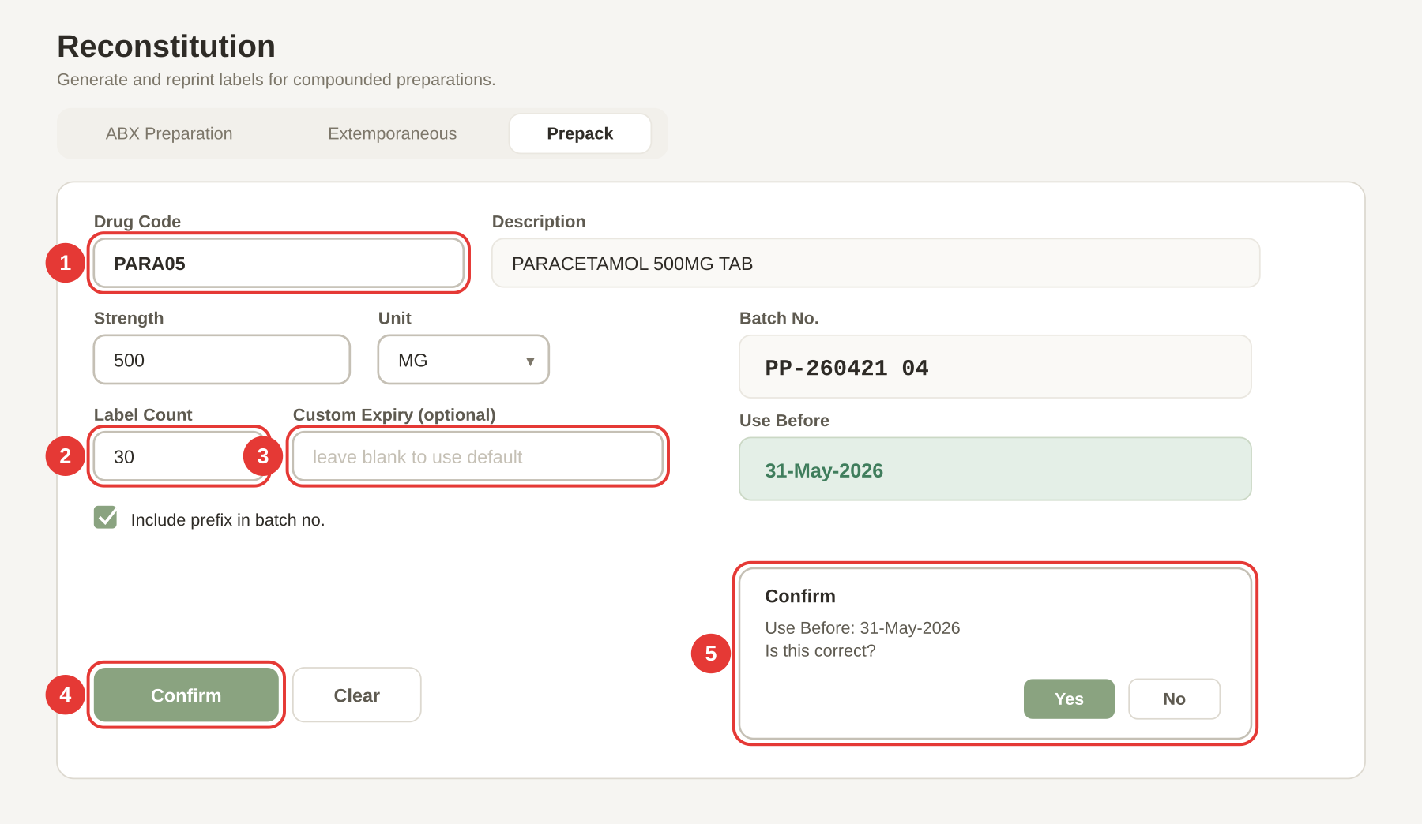
Follow the red numbers on the picture above.
① Choose a drug code from the Drug Code drop-down. For example PARA05 for Paracetamol 500mg tab. The Description field fills in on the right.
② Type the Strength. The strength shown on the label, for example 500. This will be added to the description, so the sticker reads PARACETAMOL 500MG TAB 500MG. Leave it blank if the description already has the strength in it.
③ Choose the Unit. Pick from MG, MCG, G, ML, IU, %, or MMOL in the drop-down.
④ Click 🖨 Confirm & Print. The app asks you one more time: Use Before: DD-Mon-YYYY — Is this correct?. This is the double-check popup (red callout 5 on the picture).
⑤ The Confirm popup.
- Click OK / Yes if the use-before date looks right → the labels print.
- Click Cancel / No if you want to type a different expiry → a new Override Use Before Date box appears. Type the correct date as DD/MM/YYYY and click Confirm to print with your override.
Before you hit Confirm, tidy up the small details on the left:
- Number of Labels — how many labels you want out of the printer for this prepack run.
- Include prefix in batch no. — tick on to get a prefix (for example PP-260421 04); tick off for a plain 260421 04.

What if something goes wrong?
- "Please select a drug code." — Pick one from the drop-down first.
- "No expiry date — check expiry rules or enter one manually." — The drug has no Active Expiry Rule and you did not type a Custom Expiry. Either add a rule in Maintenance → Expiry Rules, or type a date in Custom Expiry (optional).

6. EV54 Tools
EV54 Tools help you work with the EV54 dispensing robot. Two tabs — one to make a pick-list before you refill the robot, and one to print a QR-code label for a bottle.
Tab | When to use it
Print Pick List | Before you refill the EV54. Build a list of drug codes + quantities and print a sorted pick-list on A4 paper.
Print GTIN Label | For a bulk bottle that you will feed into the robot. Prints a QR code of the drug's GTIN plus the item code.

6a. Print Pick List
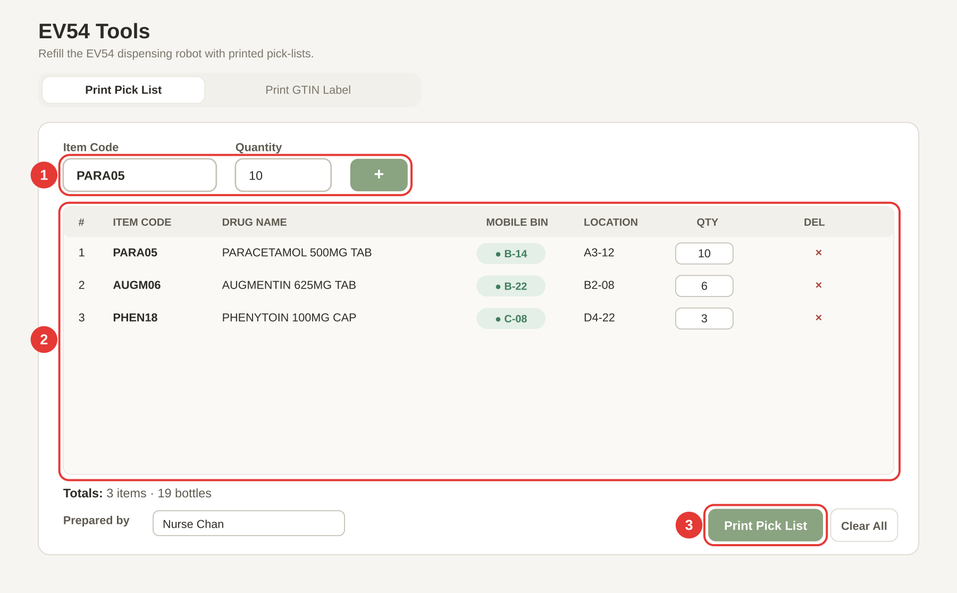
Follow the red numbers on the picture above.
① Add items one at a time.
- Type the 6-character Item Code (for example PARA05) and press Enter → the cursor jumps to the Quantity box.
- Type the Quantity (how many bottles you will pick) and press Enter → the row is added to the list below.
- The cursor jumps back to the Item Code box so you can add the next drug.
- If you add the same item code twice, the app merges the two entries and highlights the row in blue for a moment — it does not create a duplicate.
② Check the list in the middle of the page. Every added drug shows up as a row: # · Code · Drug name · Location · Qty · ×.
- The Location column shows the pick location. If the drug lives on the mobile refill shelf, you see a green pill like ● B-14 — this takes priority over the normal shelf location.
- The Qty box on each row is editable — click it to change the quantity without deleting the row.
- Click the red × at the right end of a row to delete that drug.
- Clear All wipes every row (asks you first).
③ Click 🖨 Print to print the pick-list. Type your name in the Prepared by box first (it goes on the printed A4 page). Then click 🖨 Print. The app sorts all the rows by location before printing so you can walk the shelves in order without backtracking. You will see the totals at the bottom: for example 3 items · 19 bottles · Plastic containers required: 3.

What if something goes wrong?
- "Item code must be 6 characters" — Your code is too short or too long. Item codes are exactly 6 characters.
- "Item code "XXXXXX" not found in PHQ data" — The code is not in the drug list. Import the latest drug list (Chapter 7d), or check for a typo.
- "XXXXXX is not on the EV54 drug list" — The code is in the drug list but the admin has restricted pick-lists to the EV54 allowlist. Ask an admin to either add this drug to Maintenance → EV54 Drugs, or turn off the restriction in Maintenance → EV54 Allowlist.
- "Quantity must be at least 1" — Type a whole number of 1 or more.

6b. Print GTIN Label
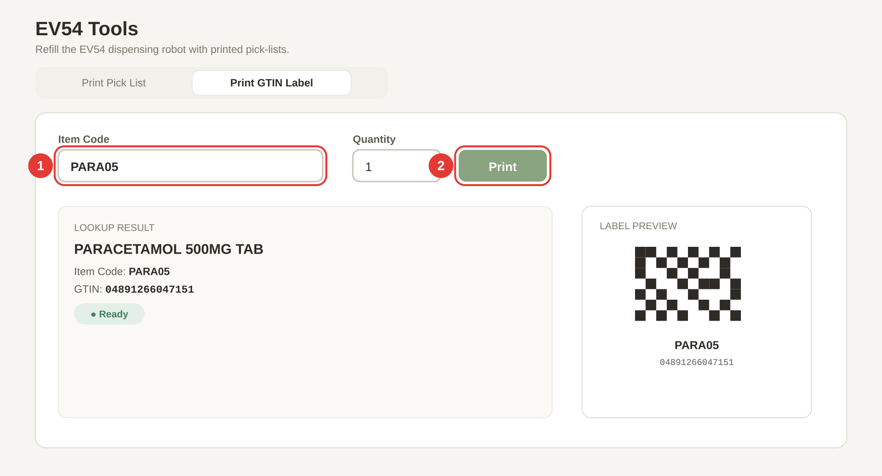
Follow the red numbers on the picture above.
① Type the 6-character item code in the Item Code box. For example PARA05. As soon as you finish typing (after the 6th character), the app looks up the drug in the drug list and the GTIN in the GTIN map. A small preview card appears below showing the drug name, item code, and GTIN. A green pill reads ● Ready once both are found.
② Set the Quantity and click 🖨 Print Label.
- Type how many labels you want (1 to 99).
- Click 🖨 Print Label (or just press Enter in the item code box once the preview is green).
The label is a small sticker with a QR code of the full GTIN and the item code in text below the QR. The QR is sized automatically to fill the label; you can tweak it in Settings → GTIN QR Label if you need smaller text.

What if something goes wrong?
- "Item code not found in drug list." — The 6-letter code is not in the drug list. Import the latest drug list (Chapter 7d).
- "No GTIN found for this item code. Check GTIN map in Maintenance." — The drug is in the list, but it has no GTIN recorded. Reload the GTIN database in Maintenance → GTIN Database → Reload from DB.
- The QR code is too small / too big on the label. Go to Settings → GTIN QR Label and type a QR size in mm (0 = auto-fit).

7. Maintenance
Maintenance is where the drug list, batches, expiry rules, and GTIN data live. It is PIN-protected — only senior staff should use it.

7a. Unlocking Maintenance
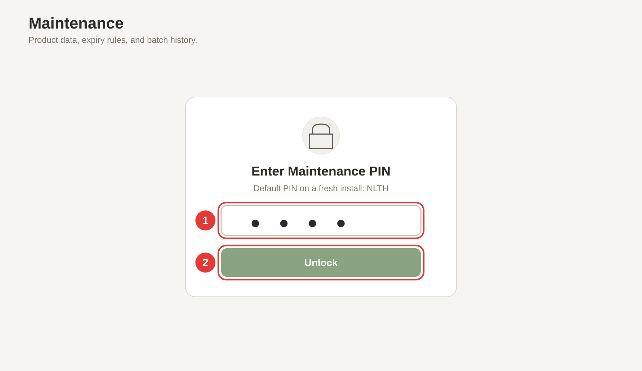
When you click Maintenance on the left rail for the first time, the app shows the PIN screen.
① Type the PIN in the password box. The default PIN on a fresh install is NLTH (four capital letters). The box hides the letters with dots as you type.
② Click Unlock.
- If the PIN is right → the Maintenance page opens.
- If the PIN is wrong → a red message shakes on screen: Incorrect PIN. Please try again. The box clears so you can try again.
Change the default PIN on first use. NLTH is printed in this guide, so anyone who reads the guide knows it. Go to Settings → Change Maintenance PIN (Chapter 8a) and pick a PIN only your team knows. If you lose the new PIN, an admin will need to reset it.

7b. Finding your way around
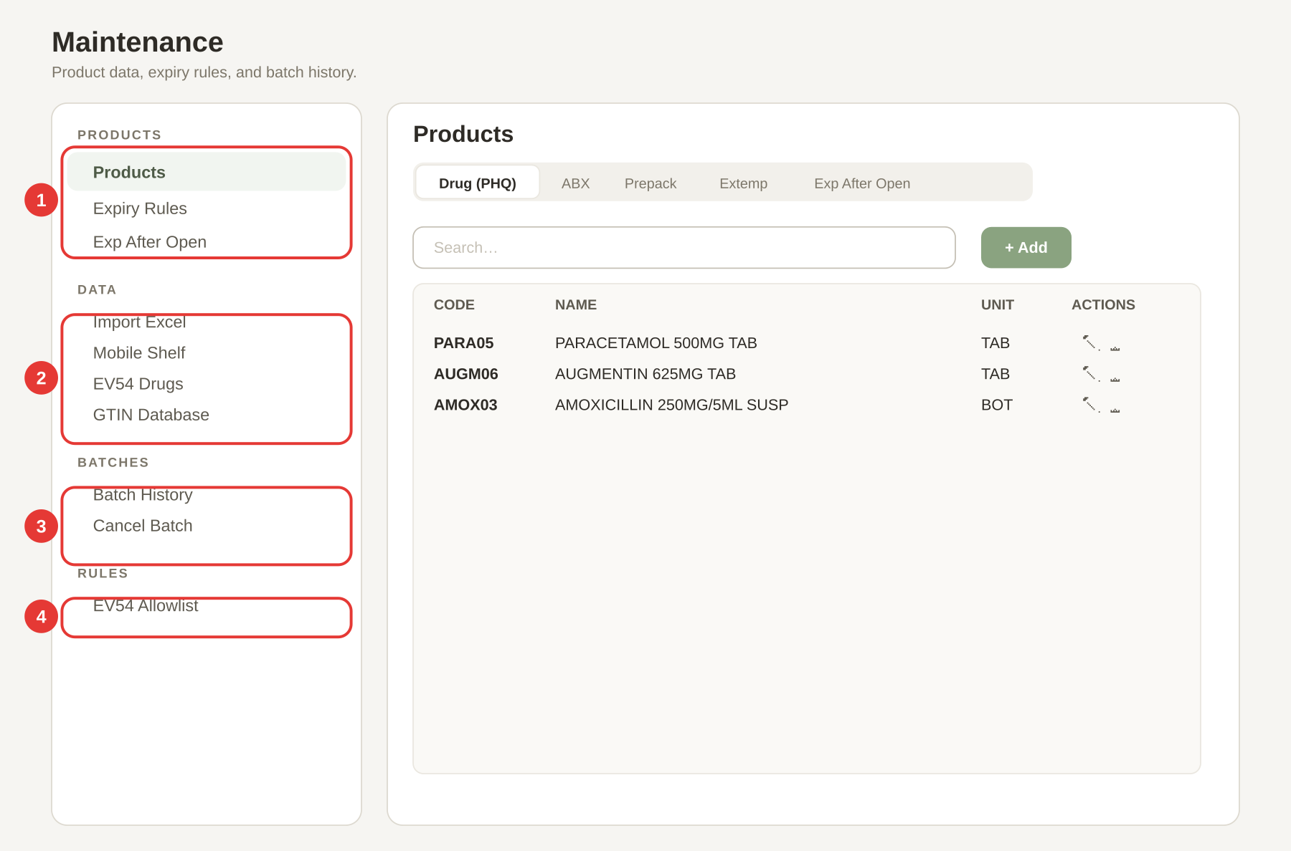
Once you are in, Maintenance is split into four groups down the left side. Follow the red numbers above.
① PRODUCTS group. The drug lists that the rest of the app reads from.
- Products — the main drug list (PHQ) plus the ABX / Prepack / Extemp / Exp-After-Open mini-lists. Use the tabs at the top of the page to switch between them.
- Expiry Rules — shelf-life rules per drug and manufacturer.
- Exp After Open — how many days a drug is good for after opening (used by Small Label Print → Short Exp).
② DATA group. Read-only viewers and the Excel importer.
- Import Excel — bring a spreadsheet into the app. This is where fresh PHQ / GTIN / Location lists go. See 7d below.
- Mobile Shelf — read-only table of drugs on the mobile refill shelf.
- EV54 Drugs — read-only table of drugs approved for the EV54 robot.
- GTIN Database — read-only GTIN → item code map. Has a Reload from DB button to refresh it from the Access .accdb file.
③ BATCHES group. The audit trail for every printed batch.
- Batch History — list of every batch printed from the Reconstitution page.
- Cancel Batch — mark a batch as cancelled (keeps the record but flags it as void).
④ RULES group. Feature rules.
- EV54 Allowlist — turn on/off the rule that says "only drugs on the EV54 list can go on a pick-list". See 6a.

7c. The Products sub-tabs
Click Products and the main area shows five mini-tabs across the top: Drug (PHQ) · ABX · Prepack · Extemp · Exp After Open. Each tab shows a searchable table with + Add, edit (✏️), and delete (🗑️) buttons. Use these when you want to add or fix a single item by hand.
For bulk changes (hundreds of drugs at once), use Import Excel instead — it is faster and less error-prone.

7d. Import Excel — the most common Maintenance job
When a new drug list, GTIN list, or location list arrives, this is where you bring it in.
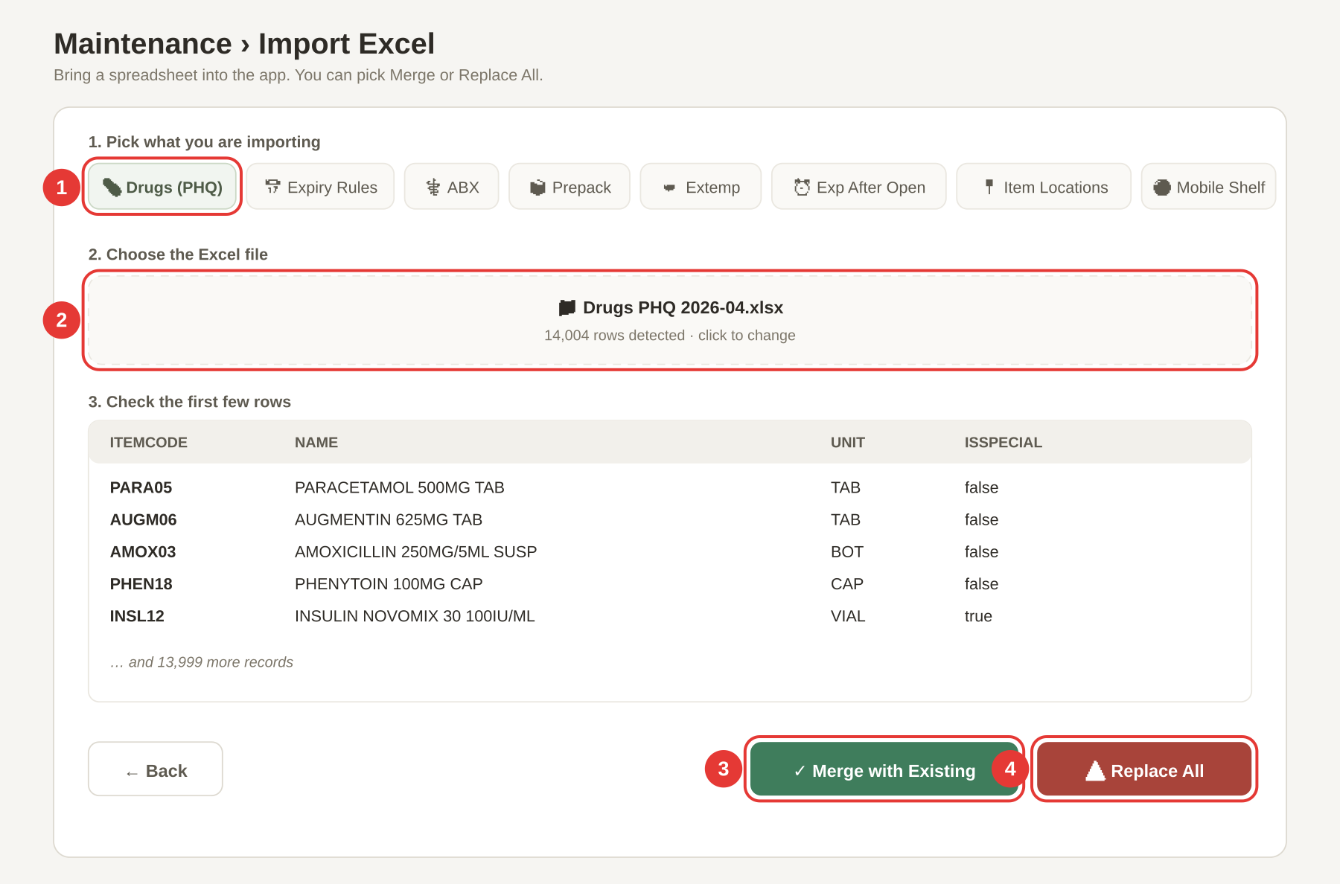
Follow the red numbers on the picture above.
① Pick what you are importing. Click one of the pill buttons along the top: 💊 Drugs (PHQ), 📅 Expiry Rules, ⚕️ ABX, 📦 Prepack, ⚗️ Extemp, ⏰ Exp After Open, 📍 Item Locations, 🟢 Mobile Shelf, or 🤖 EV54 Drugs. Each pill tells the app how to read the columns in your file.
② Choose the Excel file. Click the dashed upload box (labelled Select Excel File (.xlsx)) and pick the .xlsx file. The app reads the first sheet, pulls out the rows it recognises, and shows you:
- The sheet name (for example Drugs PHQ 2026-04.xlsx).
- How many rows it found (for example 14,004 rows detected).
- The first five rows in a preview table so you can see the data before you commit.
If the row count looks wildly wrong, click ← Back and pick a different file.
③ Click ✓ Merge with Existing. Adds your new rows to the current list — nothing is deleted. Use this to add a few new drugs without losing the existing ones. A green bar reads ✓ Successfully imported N records. (Merged with existing).
④ Or click ⚠️ Replace All. Deletes the current list and saves your new file in its place. Use this when the new spreadsheet is the complete, up-to-date list and the old one is out of date. A green bar reads ✓ Successfully imported N records. (Replaced all).
Replace All cannot be undone. Export a backup first in Settings → Data Backup & Restore → ⬇ Export Backup (Chapter 8a) before you click Replace All.

What if something goes wrong?
- "✗ No data found in Excel file" — The file is empty or the app could not read it. Open it in Excel first to check it has at least one sheet with data.
- "✗ No valid data found for selected type" — The column headers in the spreadsheet do not match what the app expects. Check the blue Expected columns hint on the import page — for Drugs (PHQ) the columns are itemCode, name, unit, isSpecial.
- "✗ Error: …" — A Read or Parse error from the file itself. Save the file as .xlsx (not .xls or .csv) and try again.

8. Settings
Settings is split into two tabs at the top: General and Admin. Both tabs need the Maintenance PIN to open the page. The Admin tab then needs a second, stronger PIN to turn feature flags on/off.

8a. General tab
Click General at the top. Scroll from top to bottom — each card controls one part of the app.

Data Sources
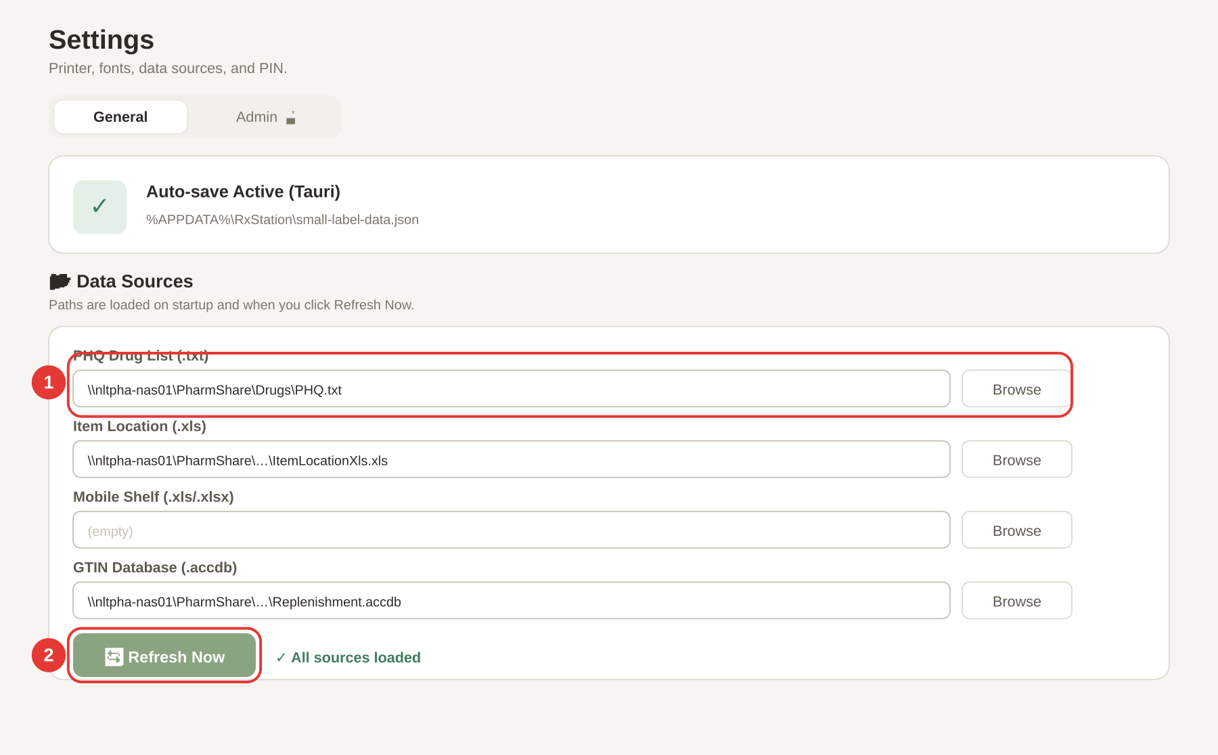
Follow the red numbers on the picture above.
① Type or browse to the file paths. These are the files RxStation reads from when it starts up. Each row has a file-path box and a Browse… button.
- PHQ Drug List (.txt) — the pipe-delimited drug list.
- Item Location (.xls) — the shelf locations spreadsheet.
- Mobile Shelf (.xls / .xlsx) — the mobile refill shelf spreadsheet.
- EV54 Drugs (.xls / .xlsx) — the EV54 robot drug list.
- GTIN Database (.accdb) — the Microsoft Access file with the GTIN → item code map.
Typical paths look like \\nltpha-nas01\PharmShare\Drugs\PHQ.txt. Paste the full UNC path or click Browse… to pick the file.
② Click 🔄 Refresh Now. Reloads every file path above right now. A green tick appears next to the button listing what was loaded (for example ✓ Refreshed: PHQ drugs, Locations, GTIN). If a path is wrong, you will see a red ✗ line instead.

General
Under the Data Sources card you will find the ⚙️ General card:
- Location — IP/OP, EC, or SM. This decides which batch counter is used when you print a reconstitution label. Default: IP/OP.
- Thermal Printer — the Windows printer name. On a Tauri desktop build, a drop-down shows every installed printer. Default: Thermal GX420t - PMS.
- PHQ Database Path — optional .mdb path for a legacy PHQ lookup.
- Show print dialog — tick this on if you want Windows to ask which printer? before each label; untick for silent printing to the default printer.
- 🖨️ Silent print (PowerShell + System.Drawing) — desktop app only. When ticked, labels are drawn pixel-perfect via GDI and sent straight to the printer.
Remember to click Save settings at the top of the page (top-right, green button). It turns into ✓ Saved for a moment so you know it worked.

Barcode Decoder Method
One card lets you pick how barcodes are parsed:
- GS1 AI Parser (default, recommended) — reads Application Identifiers (01)(10)(17) in any order. Works with QR, Data Matrix, and GS1-128.
- Legacy (P0–P6) — the old positional parser. Only use this if your scanner outputs a non-standard format that the GS1 parser cannot handle.
If your scanner keeps giving "Could not decode barcode" errors (Chapter 4a), switch to Legacy and try again.

Label Dimensions & Typography
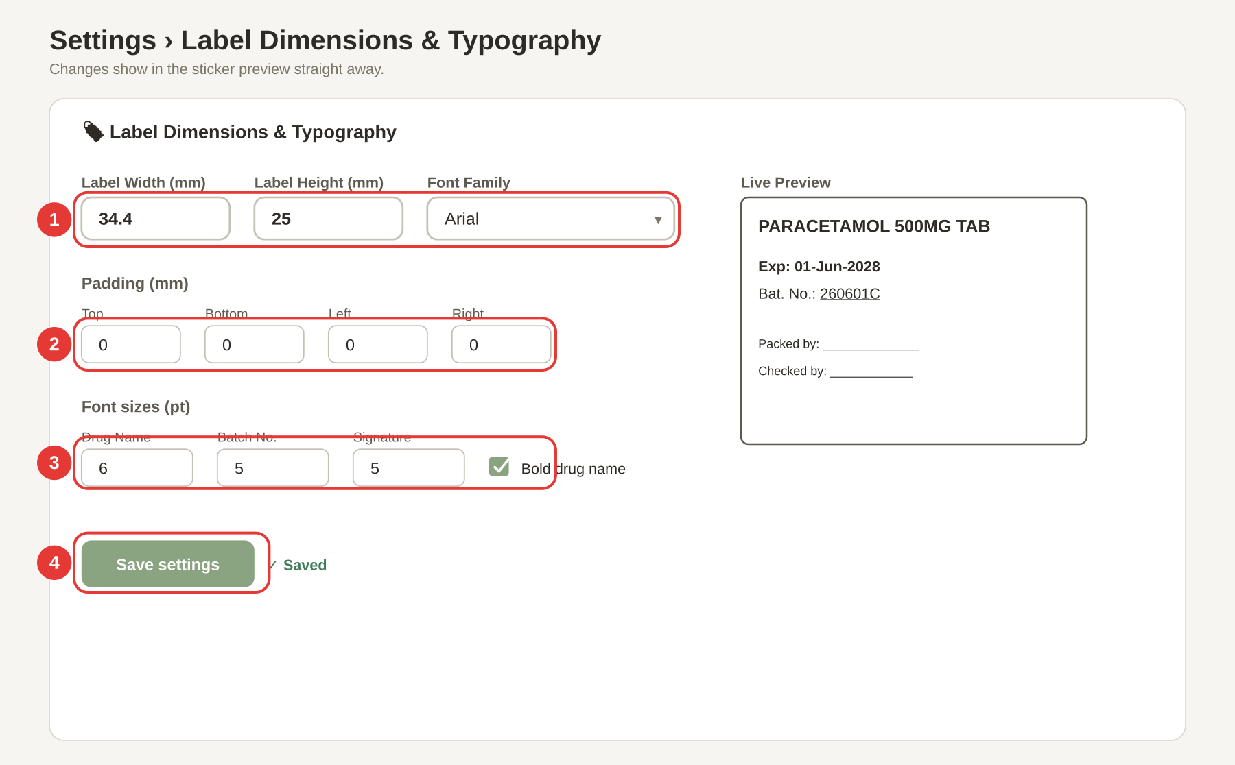
Follow the red numbers on the picture above.
① Label Width, Height, and Font Family.
- Label Width (mm) — the sticker width. Default 34.4.
- Label Height (mm) — the sticker height. Default 25.
- Font Family — Arial (default), Helvetica, Calibri, Tahoma, Verdana, Courier New, or Times New Roman.
Only change width / height if your label stock is a different size, otherwise the printed text will not line up.
② Padding (mm) — Top / Bottom / Left / Right. Empty space on each edge of the sticker. All four default to 0 mm. Increase these if the printer is cutting off the top or left of the text; decrease them if the text is too squashed against one edge.
③ Font sizes (pt) and Bold drug name.
- Drug Name — default 6 pt (and bold by default).
- Batch No. — default 5 pt.
- Signature — default 5 pt.
- Bold drug name — tick on by default.
The card finishes with a grey hint line: Default: 34.4 × 25 mm · Arial · Drug 6pt bold · Batch 5pt · Sign 5pt · No padding — handy if you want to reset after experimenting.
④ Click Save settings. At the top-right of the page. The button flashes ✓ Saved for two seconds. Your next printed label uses the new dimensions.

GTIN QR Label
A small card for the QR label printed by EV54 Tools → Print GTIN Label (Chapter 6b):
- QR Code Size (mm) — 0 means auto-fit (fill the label).
- Item Code Font Size (pt) — default 5 pt.

Change Maintenance PIN
Three boxes side-by-side: Current PIN · New PIN · Confirm New PIN. Type them all and click Change PIN. You will see ✓ PIN changed successfully. in green. Rules:
- The current PIN must match the one already on the system.
- The two new PINs must match.
- The new PIN must be at least 4 characters.
If any of these fail you get a red message: Current PIN is incorrect. / New PINs do not match. / PIN must be at least 4 characters.

Data Backup & Restore
Two buttons:
- ⬇ Export Backup — downloads a JSON file named small-label-backup-YYYY-MM-DD.json with all of the app's data (drugs, rules, records, settings). Save this file somewhere safe.
- ⬆ Import Backup — loads a previously exported JSON file. Asks you to refresh the page after.
Export a backup before any large import (especially Replace All in Chapter 7d) so you can roll back if something goes wrong.

8b. Admin tab
The Admin tab hides app features you do not use. It needs a separate PIN on top of the main Settings PIN.
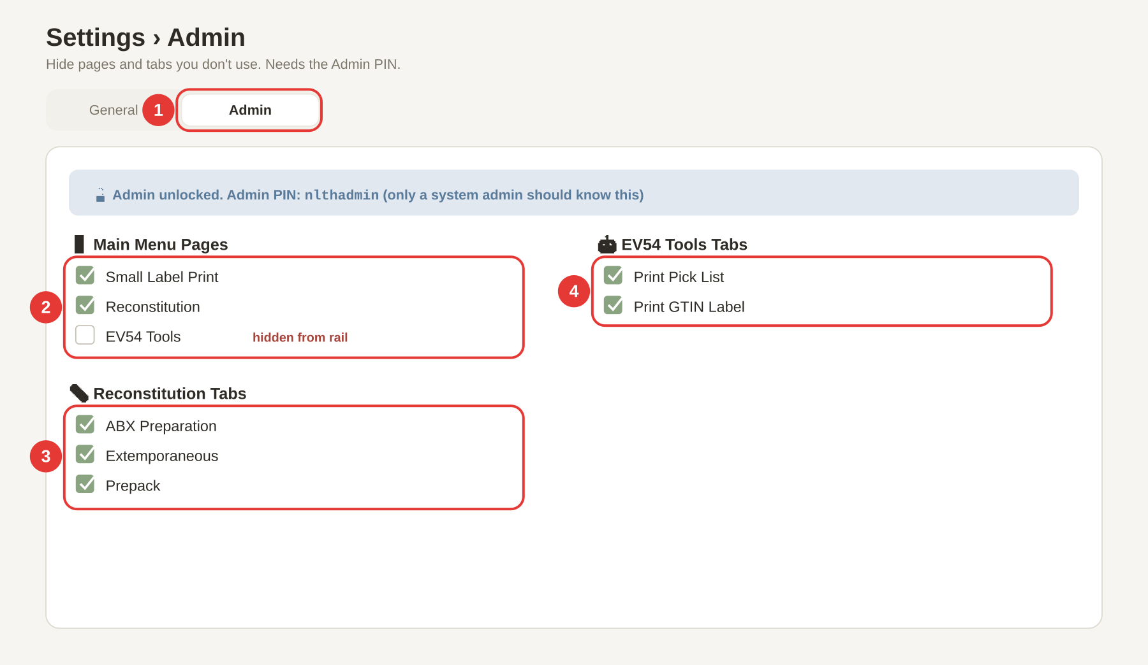
Follow the red numbers on the picture above.
① Click the Admin tab at the top. It reads Admin 🔒 when locked. A small card pops up asking for the Admin PIN. Type nlthadmin (all lowercase) and click Unlock Admin. Only a system admin should know this PIN — do not share it with ward staff.
② Turn Main Menu Pages on or off. A list of the three main work pages:
- Small Label Print
- Reconstitution
- EV54 Tools
Untick a box → the matching button disappears from the left rail. Tick it back → the button reappears. Use this to hide features that are not used on this PC.
③ Turn Reconstitution Tabs on or off. Inside the Reconstitution page, you can hide individual tabs:
- ABX Preparation
- Extemporaneous
- Prepack
Untick the ones you do not need.
④ Turn EV54 Tools Tabs on or off. Inside EV54 Tools:
- Print Pick List
- Print GTIN Label
Changes take effect straight away — no need to click Save.

What if something goes wrong?
- "Incorrect PIN" (on the admin PIN card) — The admin PIN is nlthadmin (all lowercase, no spaces). Double-check your keyboard (Caps Lock off).
- I turned Small Label Print off by mistake — how do I get it back? Unlock Admin again and tick the box. If you have lost the admin PIN, see your system administrator.

9. Everyday Recipes
One page per common job — each recipe is a short numbered list that points you at the right chapter for the details.

9a. Print an OP label (no expiry)
- Click Small Label Print on the left rail, or press F1.
- Make sure the Standard Label tab is on.
- Click inside the scan box and type the 6-character item code (for example PARA05).
- Press Enter. The label prints as an OP label (no expiry).
- Full details: Chapter 4a.

9b. Print an IP label from a GTIN scan
- Click Small Label Print on the left rail (or F1).
- On the Standard Label tab, click inside the scan box.
- Scan the GTIN barcode on the drug box.
- When the pop-up appears, click In-Patient (IP).
- If the barcode had an expiry date, the label prints straight away. If the expiry is empty, type it in as DDMMYYYY (eight digits) and click 🖨 Print Label.
- Full details: Chapter 4a + the IP/OP selection sub-section.

9c. Print a short-expiry label after opening a vial
- Click Small Label Print (or F1).
- Click the Short Exp (After Opening) tab.
- Type or scan the 6-character item code in the scan box.
- Press Enter (or click Lookup). The new expiry is worked out from today + the "Exp After Open" rule, and the label prints straight away.
- Full details: Chapter 4b.

9d. Import a new drug list from Excel
- Click Maintenance on the left rail.
- Type the Maintenance PIN and click Unlock.
- Click Import Excel in the sidebar (DATA group).
- Click the 💊 Drugs (PHQ) pill.
- Click the dashed upload box and pick the .xlsx file.
- Check the preview (sheet name, row count, first five rows).
- Click ✓ Merge with Existing (keeps current rows) or ⚠️ Replace All (deletes current rows first).
- Full details: Chapter 7d. Always export a backup first — Chapter 9e.

9e. Back up your data
- Click Settings on the left rail.
- Type the Maintenance PIN and click Unlock.
- Stay on the General tab.
- Scroll down to the 💾 Data Backup & Restore card.
- Click ⬇ Export Backup. Your browser saves a file called small-label-backup-YYYY-MM-DD.json.
- Save the file somewhere safe (a network drive, not this PC only).
- Full details: Chapter 8a → Data Backup & Restore.

9f. Change the thermal printer
- Click Settings on the left rail and unlock with the PIN.
- Stay on the General tab.
- Scroll to the ⚙️ General card.
- Under Thermal Printer, pick the new printer from the drop-down (or type its name if the drop-down is empty).
- Click Save settings at the top-right of the page.
- Print a test label from Small Label Print to check the new printer.
- Full details: Chapter 8a → General.

10. When Things Go Wrong
Every red message in RxStation has a meaning. If you see one of the messages below on screen, this table tells you what it means and what to do.
The app says… | It means… | What to do
Drug not found (XXXXXX). Import your drug list via Maintenance → Import Excel → Drugs (PHQ). | The 6-letter code is not in the drug list. | Ask an admin to import the latest drug list. Chapter 7d.
Could not decode barcode | The scanner read the label but the app cannot parse it. | Try again slowly. If it keeps failing, switch to the Legacy decoder in Settings → Barcode Decoder Method. Chapter 8a.
Unrecognised input. Enter a 6-char item code or scan a barcode. | What you typed is the wrong length. | Item codes are exactly 6 characters. Type or scan again.
Item code not found: XXXXXX | Short Exp could not find the 6-letter code in the drug list. | Import the latest drug list (Chapter 7d) or check for a typo.
No expiry-after-open rule found for this item. | Short Exp needs a rule for how long the drug lasts after opening. | Maintenance → Exp After Open — add the item and the number of days. Chapter 7.
Incorrect PIN. Please try again. | The Maintenance PIN you typed is wrong. | Default PIN is NLTH. If your team changed it and you lost the new one, ask a system admin.
Incorrect PIN (on the Admin card in Settings) | The Admin PIN is wrong. | Admin PIN is nlthadmin (all lowercase). Only system admins should know this.
Please select an item code. | You clicked Confirm & Print on a Reconstitution tab without picking an item. | Pick an item code from the drop-down first. Chapter 5.
Please select a manufacturer. | ABX tab — no manufacturer chosen. | Pick one from the Manufacturer drop-down. Chapter 5a.
Could not calculate expiry — check expiry rules in Maintenance. | No Active expiry rule exists for the drug + manufacturer pair. | Maintenance → Expiry Rules — add an Active rule. Chapter 7.
No expiry rule found — add one in Maintenance. | Extemp / Prepack — the drug has no Active Expiry Rule. | Maintenance → Expiry Rules — add a rule. Chapter 7.
No expiry date — check expiry rules or enter one manually. | Prepack — no rule and no custom expiry. | Add a rule, or type a date in Custom Expiry (optional). Chapter 5c.
Item code must be 6 characters | EV54 pick-list — your code is the wrong length. | Item codes are exactly 6 characters. Chapter 6a.
Item code "XXXXXX" not found in PHQ data | EV54 — the code is not in the drug list. | Import the latest drug list. Chapter 7d.
XXXXXX is not on the EV54 drug list | EV54 pick-list is restricted to the EV54 allowlist. | Maintenance → EV54 Drugs — add the item, or turn off the restriction in Maintenance → EV54 Allowlist. Chapter 7.
Quantity must be at least 1 | EV54 pick-list quantity is blank or zero. | Type a whole number of 1 or more.
Item code not found in drug list. | GTIN Label — the code is not in the drug list. | Import the drug list. Chapter 7d.
No GTIN found for this item code. Check GTIN map in Maintenance. | The drug is in the list but has no GTIN. | Maintenance → GTIN Database → Reload from DB. Chapter 7b.
Current PIN is incorrect. | Change PIN — the current PIN you typed is wrong. | Try again. If lost, ask a system admin.
New PINs do not match. | Change PIN — the two new PINs differ. | Type the same PIN in both New PIN and Confirm New PIN.
PIN must be at least 4 characters. | Change PIN — new PIN is too short. | Pick a PIN of 4 characters or more.
✗ No data found in Excel file | Import Excel — the file is empty or unreadable. | Open in Excel to check it has data, save as .xlsx, try again.
✗ No valid data found for selected type | Import Excel — column headers do not match the expected shape. | See the blue Expected columns hint on the import page. Chapter 7d.
✗ Import failed — invalid file format. | Restore Backup — the JSON file is not a valid RxStation backup. | Make sure you picked a file named small-label-backup-*.json. Chapter 8a.

11. Keyboard Shortcuts
A handful of shortcuts work everywhere in RxStation. The ones with a badge on the left rail are the important ones.
Shortcut | What it does
F1 | Jump to Small Label Print.
F2 | Jump to Reconstitution.
F3 | Jump to EV54 Tools.
Ctrl+K (or ⌘K on macOS) | Focus the global search box in the top bar.
Enter | In any scan/input box — submit what you typed (item code, barcode, quantity).
Enter (in the EV54 pick-list Item Code box) | Jump to the Quantity box.
Enter (in the EV54 pick-list Quantity box) | Add the row to the list and jump back to Item Code.
Tip: If F1 / F2 / F3 do nothing, click once on the app window to give it keyboard focus, then try again. These shortcuts only work while RxStation is the active window.

